|  |
| --- |
| Riki Tours |
| This project is the product of the combined efforts of a group of third year Information Technology students from Cape Peninsula University of Technology. |
| |  |  |  | | --- | --- | --- | | Name | Student Number | Git-Hub Account | | Ayowa Berka | 214013294 | berkaayowa | | Catodie Tammone | 214078353 | tamonne | | Mabuya Lindokuhle | 213036223 | LindorMabuya | | Madikane Richard | 210152869 | MadikaneRN | | Mesias Shaun | 213225026 | chief26 | | Mphokeli Innocent | 212022644 | innothetechgeek | | Parsotam Kishan | 211059382 | Kishan666 | |

12/15/2016

Table of Contents

1. INTRODUCTION 2

1.1 About 2

2. SYSTEM CONFIGURATION 2

2.1 Installation 2

2.2 Running the App 2

2.3 Start Up 2

3. DATA FLOWS 3

3.1 Login instructions 3

3.2 Command Sequences and Functions 3

4. GETTING STARTED 8

4.1 Application Menu 8

4.2 Exit Application 8

# 1. INTRODUCTION

In our fast-paced and demanding lifestyle, planning a business trip or holiday can be an expensive, time consuming and often frustrating process. But with Riki Tours Travel Packages, guests can now book tour guides, hire a car and reserve hotel accommodation all at the same time! Booking a value-for-money travel package has never been this quick, easy and convenient.

Our variety of cost-effective travel package options ensures that we have the perfect travel package for you. Once you've identified your ultimate travel package, follow our booking and payment prompts and instructions. We will then send you an email confirming your booked trip.

### About

Riki Tours (Pty) Ltd was established in the early year of 2014, by Mr. Ricardo Joao D.A and Mrs. Visa G based in Cape Town, Western Cape Province.

The primary key services of Riki private tours is to deliver a full travel service to people locally and from abroad, both corporate and individuals. Our services include, but not limited to airport transfers cape town, chauffeur drive services, pre-arranged tours packages that includes cape point tour, cape town city tour, garden route tour, gorilla tour, safari private day tour, shark cage diving tour, cape township tour, cape whale watching tour, cape wine lands tour, air ticketing sales, car rental service assistance, accommodation services, and so much more.

# 2. SYSTEM CONFIGURATION

### 2.1 Installation

Download the application from Google play store [<https://play.google.com/store/apps/details?id=za.co.whcb.tp2.rikitours&hl=en>] after downloading press install

### 2.2 Running the App

Click or press on the icon follow the instructions on the Main Menu Screen

### 2.3 Start Up

* The application must provide a user interface.
* The application authentication must use a user login and encrypted password.
* The application must provide the user role authorization that should provide way of assigning users to specific operations and tasks.
* The application must provide the means for the end user to define the application’s operations and tasks.

Rational: various users will use the application across various locations. The application needs to be protected from unauthorized users/access to prevent malicious activities. The application will need to provide the means to limit access and functions of the system by user. An admin may have the ability to create, modify, and delete information, but a user can only browse or make bookings. That’s how RikiTours want the app to operate they don’t want to have an Admin section on the App itself. Once everything is done the user will get sent an email confirmation of his reservations or bookings

# 3. DATA FLOWS

### 3.1 Login instructions

1. Inputs

* Login (A unique username, containing at least 4 but no more than 30 characters)
* Password (An alphanumeric code containing at least 7 but no more than 20 characters. It must contain at least one alpha character and at least one numeric character.)

1. Processing

Upon the user entering their Login and Password the application should authenticate the user checking for a valid Login ID and Password. If the user enters an invalid Login ID or Password, then a message will be displayed indicating that the login attempted failed. If the same Login ID fails 3 times in a row, then that ID will be locked out. A message will be displayed indicating that the maximum number of failed Login attempts has been reached and an administrator must reset the Login ID. Else, if the user is valid then they will be presented with their appropriate entry screen.

1. Outputs

* Login screen
* Error message indicating failed login attempt or maximum failed attempts.
* Appropriate user entry screen after successful login.

### 3.2 Command Sequences and Functions

1. **Login**: Registered user logins, else they register for full access to the application.

*Figure 1: Login Screen*

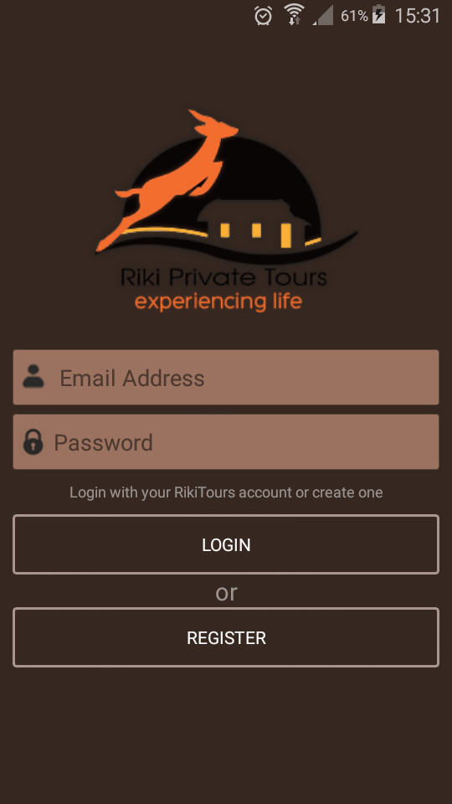

*Figure 2: Registration Screen*

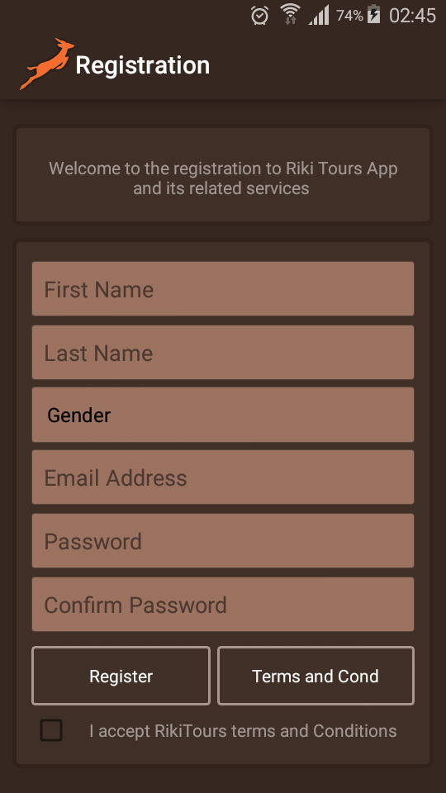

1. **View Categories and Products**: Lists products that a user can make a selection from. Each product is categorized accordingly and user can view products by categories.

*Figure 3: Product Category*

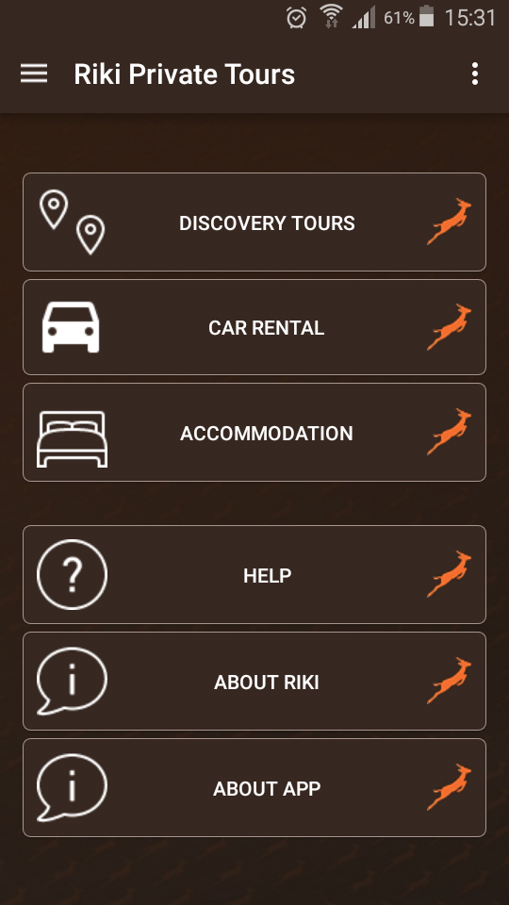

#### Tours

*Figure 4: Private Tours*

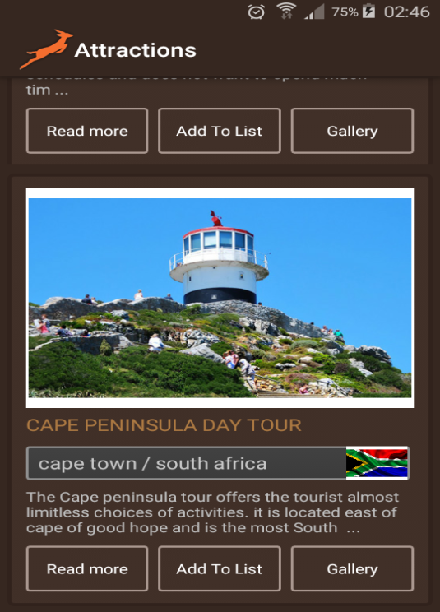

Riki tours provide a range of private tours around Cape Town. Tours include cape peninsula tour, cape wine lands tour, Cape Town city tour, cape township tours, whale watching tour, shark cage driving tour, big 5 safari tour, garden route tour and more.

#### Car Rentals

*Figure 5: Car Rentals*

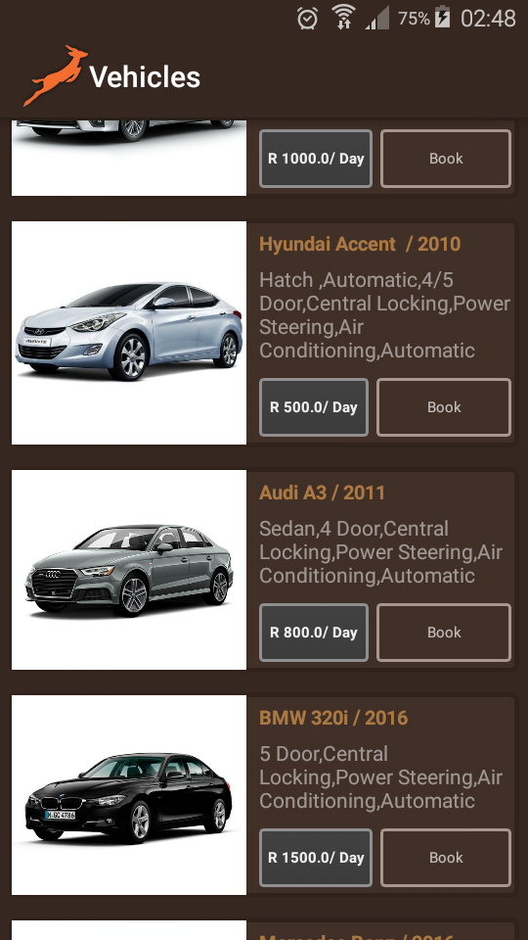

Riki private tours are renowned Car rental assistance for its clients by offering a quick assistance when it comes to booking or car reservation. We provide Car rental assistance in Cape Town. Should you prefer to be driven, you can hire a well-mannered and co-operative driver. We assist our valued customers to hire Premium cars, VIP cars, budget cars, Van, etc.

#### Accommodation

*Figure 6: Accommodation*

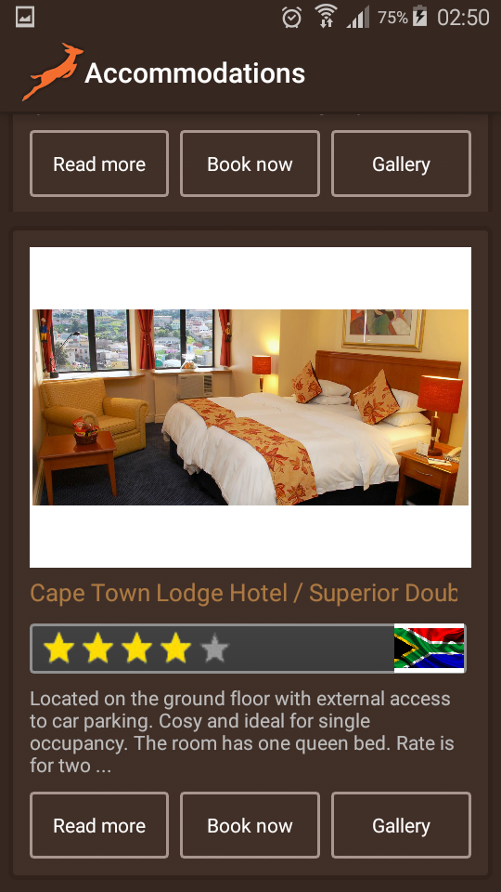

Riki tours provide a distinguished assistance when it comes for the hotel reservation. We have numerous renowned hotels, resorts, spa, guest house, and many other type of accommodation. We offer the finest luxury 5 star Hotels, Resorts, Villas, Guest houses, B&B, Apartments, Boutique hotels and Self-catering accommodation.

1. **Make bookings**: Given that a user is logged in, they can add selected products to their wish list and make bookings.

*Figure 7: Booking Screen*

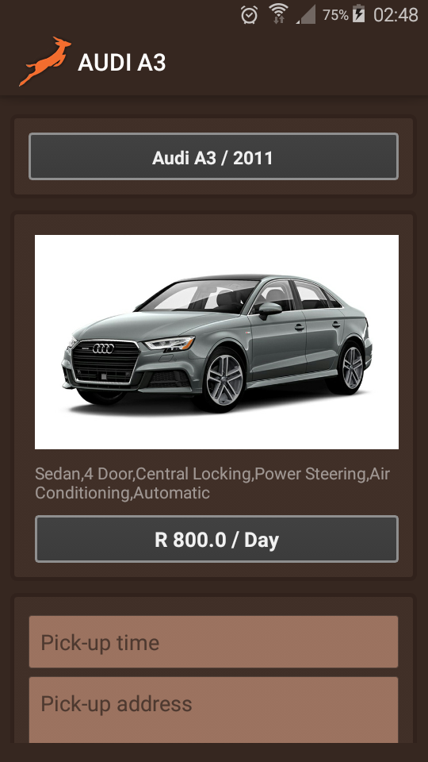

1. **Confirm Booking**: User can manipulate wish list. They can add/remove products from list. An email will be sent confirming bookings.
2. **Sign out**: After a user has completed the tasks at hand and all transactions have been successfully recorded, the user can log off.

*Figure 8: User Profile*

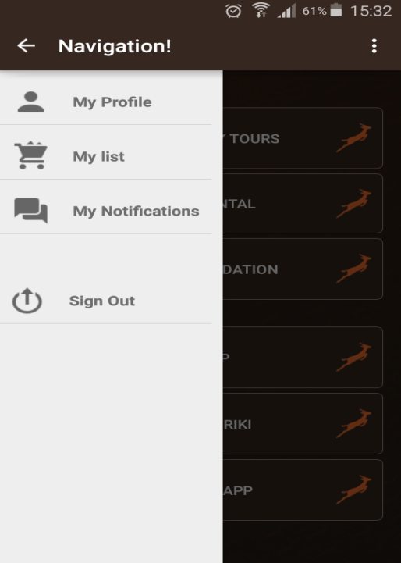

# 4. GETTING STARTED

### 4.1 Application Menu

The application would have the following functions:

* Display the entire product’s category available for booking on the application’s main page.
* Display all the items linked to each category listed on the main page.
* Allow the administrator to add new items to the existing list of available items.
* Allow administrator to remove items.
* Allow the administrator to modify the price of each item.
* Allow the administrator to update the description about each item.

When a new customer visits the application he should be able to browse products. However, in order make bookings he/she has to subscribe for a membership. The customer should be able to receive booking confirmations by email. In addition, the customer should be able to see his/her booking history and also receive an email newsletter from the system containing news about products and special offers.

Steps:

* Customer subscribes for membership by providing personal information.
* Customer browses product and can add to wish list.
* Customer makes booking.
* The customer will receive an email confirming booking.

### 4.2 Exit Application

After a user has completed the tasks at hand and all transactions have been successfully recorded in the database the user has to head back to the home page and click logout.